|  |  |  |  |  |  |  |
| --- | --- | --- | --- | --- | --- | --- |
| Domain: **Fashion Application** | | | | | | |
| Module 1: **Login** | | | | | | |
| Sr.no |  | House of chikankari | Snitch | Bewakoof | Myntra | Flipkart |
| 1 | Functionality | -Login contain emailed and password or can create a new user account | -User can login using the mobile number and otp | - User can login using the mobile number and otp | - User can login using the mobile number and otp | - User can login using the mobile number and otp |
| 2 | Screen Shot |  |  |  |  |  |

|  |  |  |  |  |  |  |
| --- | --- | --- | --- | --- | --- | --- |
| Module 2: **Hero** | | | | | | |
| Sr.no |  | House of chikankari | Snitch | Bewakoof | Myntra | Flipkart |
| 1 | Functionality | -Dashboard is the main page where users see the different categories like search bar,categories of products,hover property on categories where users see the list of subcategories,links for different categories. | -On the dashboard users can see different categories like search bar,categories of products,hover property on categories where users see the list of subcategories | -On the dashboard users can see different categories like search bar,categories of products,hover property on categories where users see the list of subcategories. | -On the dashboard users can see different categories like search bar,categories of products,hover property on categories where users see the list of subcategories. | -On the dashboard users can see different categories like search bar,categories of products,hover property on categories where users see the list of subcategories. |
| 2 | Screen Shot |  |  |  |  |  |

|  |  |  |  |  |  |  |
| --- | --- | --- | --- | --- | --- | --- |
| Module 3: **Product Details** | | | | | | |
| Sr.no |  | House of chikankari | Snitch | Bewakoof | Myntra | Flipkart |
| 1 | Functionality | -User can see the whole product details. And add it to cart or can directly move to payment | -User can see the whole product details. And add it to cart or can directly move to payment | -User can see the whole product details. And add it to cart or can directly move to payment | -User can see the whole product details. And add it to cart or can directly move to payment | -User can see the whole product details. And add it to cart or can directly move to payment |
| 2 | Screen Shot |  |  |  |  |  |

|  |  |  |  |  |  |  |
| --- | --- | --- | --- | --- | --- | --- |
| Module 4: **Cart** | | | | | | |
| Sr.no |  | House of chikankari | Snitch | Bewakoof | Myntra | Flipkart |
| 1 | Functionality | -User can see the items which he added to cart and can modify it | -User can see the items which he added to cart and can modify it | -User can see the items which he added to cart and can modify it | --User can see the items which he added to cart and can modify it | --User can see the items which he added to cart and can modify it |
| 2 | Screen Shot |  |  |  |  |  |

|  |  |  |  |  |  |  |
| --- | --- | --- | --- | --- | --- | --- |
| Module 5: **Add Address** | | | | | | |
| Sr.no |  | House of chikankari | Snitch | Bewakoof | Myntra | Flipkart |
| 1 | Functionality | -User can add new delivery address. | -User can add new delivery address. | -User can add new delivery address. | -User can add new delivery address. | -User can add new delivery address. |
| 2 | Screen Shot |  |  |  |  |  |

|  |  |  |  |  |  |  |
| --- | --- | --- | --- | --- | --- | --- |
| Module 6: **Checkout** | | | | | | |
| Sr.no |  | House of chikankari | Snitch | Bewakoof | Myntra | Flipkart |
| 1 | Functionality | -User can make payments and check the final details before payment | --User can make payments and check the final details before payment | -User can make payments and check the final details before payment | -User can make payments and check the final details before payment | --User can make payments and check the final details before payment |
| 2 | Screen Shot |  |  |  |  |  |

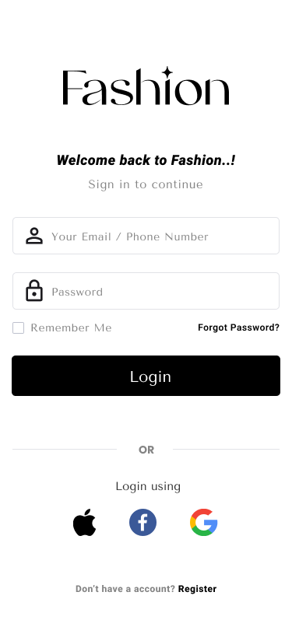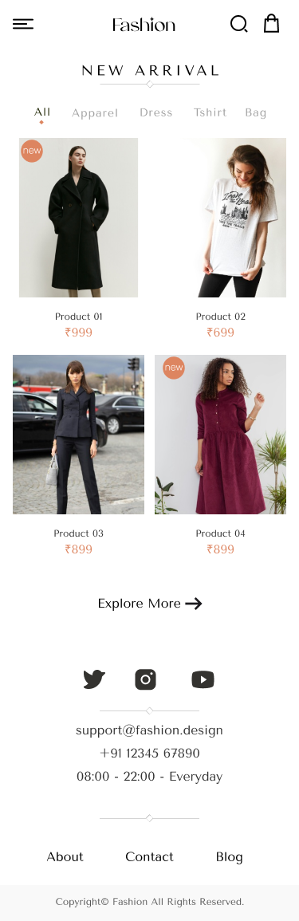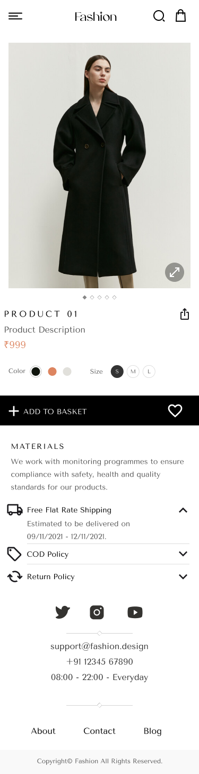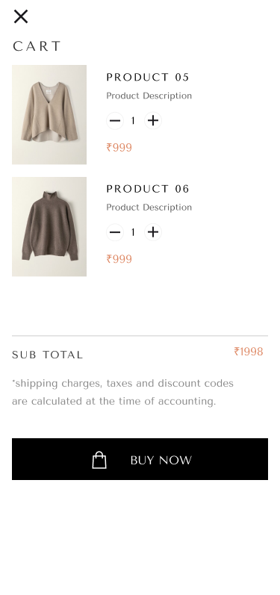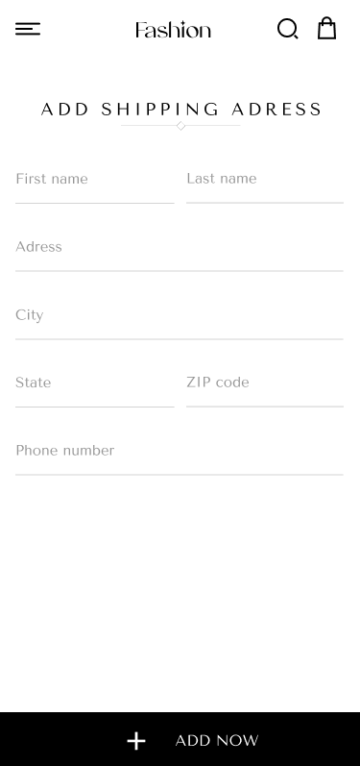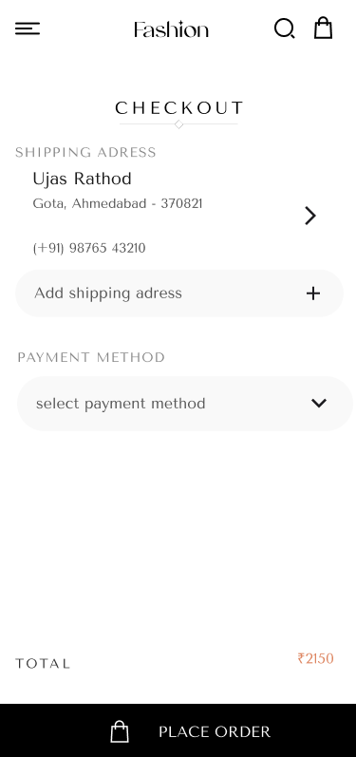

https://www.figma.com/file/xLBBhdGhHpyumUkDkOXlvu/SEM?type=design&node-id=0%3A1&mode=design&t=IyEW0jRTlkCGKX3g-1